The Pillars of the World

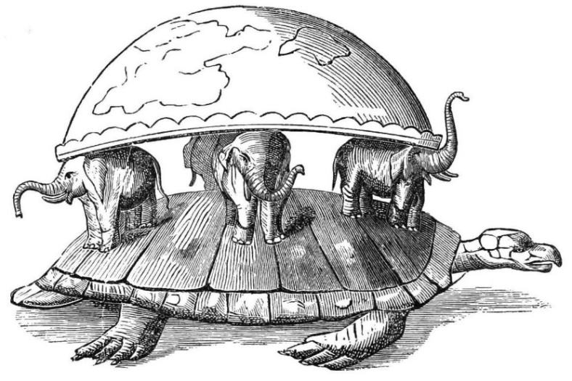
Introduction
Pirkei Avos 1:6
Shimon the Righteous (Tzaddik) was one of the remnants of the Great Assembly. He used to say, “The world stands on three things – on the Torah, on Service [in the Holy Temple and/or prayer to God], and upon acts of loving-kindness.”

Pri Megadim, Orach Chaim 670
Ancient Greeks forbade the Jews from involvement in Torah, service, and acts of loving-kindness, which is why there is a special emphasis on them during Chanukah. Torah – we increase our Torah learning; Service – we say special prayers, thanking God for the miracles He performed for us; Acts of loving-kindness – we give charity and make festive meals.

Talmud Yoma 69a
The twenty-fifth of Tevet is a day of celebration- the day of Mount Gerizim- on which no fasting is permitted. It is the day on which the Samaritans demanded the House of our God from Alexander the Great in order to destroy it, and he gave it to them. People came and informed Shimon the Righteous. What did he do? He put on his priestly garments, and robed himself in priestly vestments, and some of the noblemen of Israel went with him carrying fiery torches in their hands. They walked all night, some on one side and some on the other, until the dawn rose. When the dawn rose, Alexander asked the Samaritans, “Who are these people?” They answered, “The Jews who rebelled against you.” As he reached Antipatris, the sun rose, and they met. When Alexander saw Shimon the Righteous, he descended from his carriage and bowed down before him. They said to him, “A great king like yourself should bow down before this Jew?” He answered, “It is his image that leads me to victory in all my battles.”

The following excerpt is an insight that helped our nation go through 4 Exiles while staying strong and prevailing until this day.

Leviticus 26:44
And yet for all that, when they are in the land of their enemies, I will not reject them, nor will I abhor them, to destroy them utterly, and to break My covenant with them; for I am the Lord their God
Talmud Megillah 11a
…(2)“Nor will I abhor them”; this was in the days of the Greeks, when I appointed Shimon the Righteous for them, and the Hasmonean and his sons, and Matisyahu the High Priest…

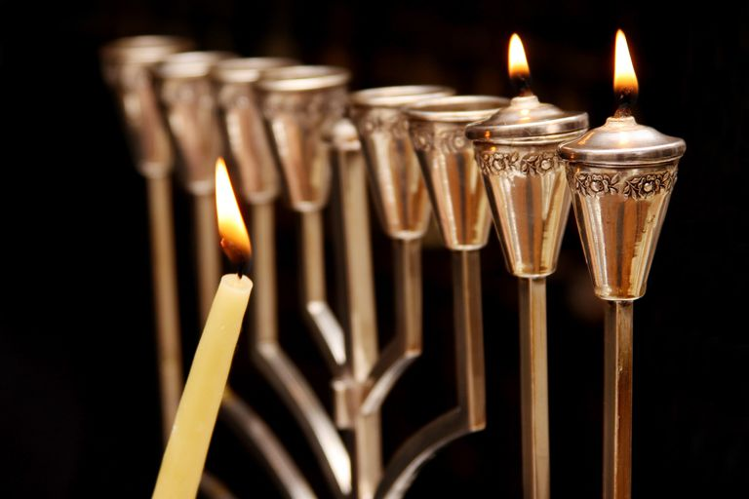

#1 Take your phone and go to www.GoldharSchool.com, scroll down to The Crash Course in Jewish Holidays.
Click 10. The Crash Course on Chanukah.
Enjoy the crash course!

#2
Google Dictionary
Foundation (faʊndeɪʃən)
An underlying basis or principle for something.

#3
Pirkei Avos 1:6
Shimon the Righteous (Tzaddik) was one of the remnants of the Great Assembly. He used to say, “The world stands on three things – on the Torah, on the Service [in the Holy Temple and/or prayer to God], and upon acts of loving-kindness.”

“The world stands on three things” – perhaps our Mishnah is referring to a different, unique world, which is probably the most important one –
Talmud Sanhedrin 37a
Whoever destroys a single life is as guilty as though he had destroyed the entire world; and whoever rescues a single life earns as much merit as though he had rescued the entire world.

#4 Question: What are the foundations for a good life? E.g. Things that give you stability, harmony, and a sense of purpose and meaning?

#5 Question: Why is it specifically these three things that Shimon the Righteous chose as foundations of the world?

(Discuss with your study partner first before looking at the possible answers below 😊!)

#6 Possible Answers:

- These three attributes address all possible relationships; a person’s interactions with:
  - Himself
  - God and
  - Other people.

Questions: Which parts of the Mishnah express which relationship? Why?
Elaborate on how these things affect the 3 relationships.

- These three attributes correspond to the three faculties of man
  - Thought
  - Speech
  - Action

Questions: Which parts of the Mishnah express which faculty of man? Why?
Elaborate on how these things affect the 3 faculties of man.

- The three attributes refer to
  - Thought
  - Emotions
  - Actions

or
- IQ - Mental Intelligence
- EQ – Emotional Intelligence
- PQ – Physical Intelligence.

Questions: Which parts of the Mishnah express which Intelligence? Why?
Elaborate on how these things affect the 3 Qs.

- The three forefathers of Jews: (a) Abraham, (b) Isaac, (c) Jacob.
  - Abraham demonstrated unparalleled acts of kindness. He kept an open home and actually ran to do goodness (see example in Genesis 18:1).
  - Isaac represented service – he was ready to offer himself as a sacrifice to God, and he spoke with God through prayer (Genesis 24:63).
  - Jacob represents Torah – the Torah calls him A man of simplicity and wholesomeness abiding in tents – (Bereishis 25:27) alluding to his constant Torah study (Rashi 28:11).

#7 Question: How would you apply these concepts and your findings to your own life and personality?

